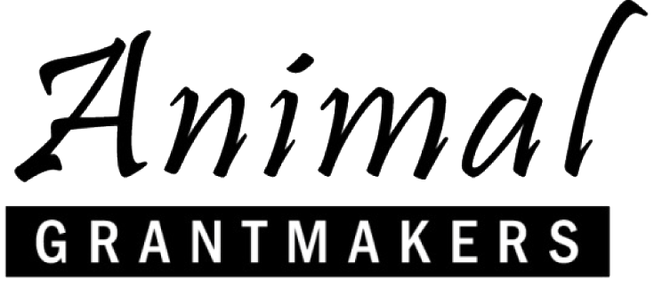

Animal Grantmakers to Host 18th Annual Conference for Animal Protection Funders October 15 – 18, 2017 in Portland, Oregon

“Animal Grantmakers Comes of Age” Procures Extensive Lineup of High-Profile Scientists, Academics and Advocates
Los Angeles – August 2, 2017 – Animal Grantmakers, a diverse group of animal philanthropists, will hold its 18th Annual Conference, “Animal Grantmakers Comes of Age,” from October 15 through 18, 2017 in Portland, Oregon. Sponsored this year by Maddie’s Fund®, PetSmart Charities® and Kirkpatrick Foundation, the affinity group’s Annual Conference is the only educational and networking event held exclusively for foundations and organizations making grants that benefit animals.
Featured speakers over the four-day meeting include Berkeley Breathed, Bloom County cartoonist and animal supporter; Ken Goddard, lab director at the U.S. Fish & Wildlife Forensics Laboratory; Dr. A. Breeze Harper, diversity strategist and author; Lewis Bollard, farm animal welfare program officer at Open Philanthropy Project; and Pamela Frasch, executive director of the Center for Animal Law Studies at Lewis & Clark Law School. Earl Blumenauer, U.S. Representative (Oregon’s 3rd District) and co-chair of the Congressional Animal Protection Caucus, is invited.
These distinguished animal protection experts and advocates will speak on a range of relevant and compelling subjects, such as threats to the Endangered Species Act, lesser-known advocacy strategies for foundations, the epic victories impacting SeaWorld and Ringling Brothers, potential setbacks for animals in the era of President Trump, counter-terrorism and crime scene investigation techniques stopping elephant poaching, why diversity and inclusion efforts are vital to animal advocacy success, and animal law in the courts and law schools in the U.S. and Europe. Complete program and registration information is available at http://conference.animalgrantmakers.org/.
“The high caliber of speakers and presentations, in addition to the fact that registration is free for members, makes the Animal Grantmakers Annual Conference a tremendous benefit of membership,” said Mitchell Fox, Conference co-chair and program officer at The Glaser Progress Foundation. “Of course, we welcome all givers of animal protection and welfare grants, and invite animal grantmaking organizations that are interested in membership to send one representative one time at no charge.”

“Animal Grantmakers Comes of Age” will come to a close with a day-long special session on animal agriculture, during which a slate of national experts will closely inspect different “cuts” of meat, including factory-farmed, pasture-raised, humane-labeled, vegetable-based, lab-grown and “skipped-on-Mondays.” A Conference highlight, the session will be capped by a visit to the Tofurky factory in Hood River, Oregon. “At the Table: A Special Session on Animal Agriculture, Attitudes & Alternatives” will be co-presented by Animal Grantmakers and Sustainable Agriculture & Food Systems Funders.

Conference-goers are encouraged to register and book their rooms early at the Hilton Portland Downtown to take advantage of unmatched opportunities to share insights with change-makers on the latest trends, victories and setbacks in the field of animal protection, and to socialize with their grantmaking peers from across the United States.

“Animal protection receives the smallest share of U.S. philanthropic dollars relative to every other major program area, including arts and culture,” said Michael Barrett, Conference co-chair and vice president of grants management at the ASPCA® (American Society for the Prevention of Cruelty to Animals®). “One of the things that excites me most about this conference is the opportunity to advance social change from an animal welfare perspective, as well as learn from each other, strengthen our work individually and collectively, and elevate the cause of animal protection within the broader field of philanthropy.”

About Animal Grantmakers
Animal Grantmakers, a tax-exempt 501(c)(3) organization, is an affinity group of foundations and organizations making grants to benefit animals. This diverse group of philanthropists works locally, regionally, nationally and internationally on the entire spectrum of animal species and issue areas, including companion animals, captive and free-ranging wildlife, farmed animals and animals used in research, among others. Animal Grantmakers serves as the principal proponent for animal protection philanthropy, facilitating communication, education, and cooperation among animal philanthropic organizations, and encouraging philanthropists and other grantmaking entities to make a significant commitment to funding that benefits animals. To learn more, please visit http://animalgrantmakers.org/.

# # #

Media Contact:
Jill Hoffman
communications@animalgrantmakers.org
323-719-7111

