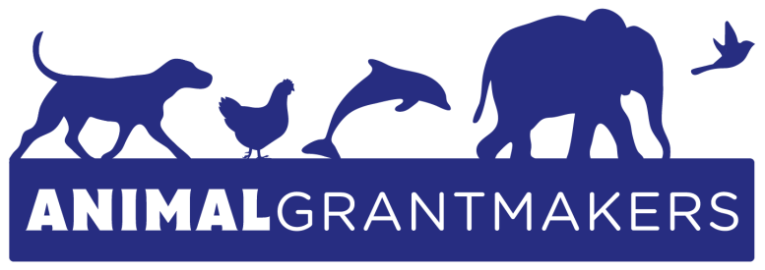

Animal Grantmakers to Hold 19th Annual Conference October 14 – 17, 2018
in Boston

Programming to Cover Array of Topics of Interest to Animal Protection Funders While Taking Advantage of Region’s Deep Marine Expertise

Los Angeles – August 21, 2018 – Animal Grantmakers, the only funder affinity group focused solely on animal protection, will convene its 19th Annual Conference October 14 – 17, 2018 in Boston, MA. It is the only educational and networking event held exclusively for foundations and organizations making grants that benefit animals. Sponsored this year by PetSmart Charities®, Maddie’s Fund®, Kirkpatrick Foundation, A Kinder World Foundation and Pegasus Foundation, the annual gathering offers an unparalleled opportunity to hear from some of the leading experts in the field of animal protection on a wide variety of challenging issues and timely topics relevant to funders.

Featured activities and speakers at the 2018 Conference will include field trips to The New England Wildlife Center, Foster Parrots and Woods Hole Oceanographic Institution (WHOI); a welcome reception; a screening of the documentary film, Sonic Sea; a keynote presentation from Dr. Michael Moore, director of the WHOI Marine Mammal Program; a wealth of expert panelists, including Dr. Stormy Mayo of the Center for Coastal Studies and Ron Kagan, head of the Detroit Zoo; and, a special session on the final day at Harvard Law School related to climate change and farm animals.

In addition to ocean and climate issues as they connect to animals, key programmatic themes to be covered include companion animals, animal protection grantcraft, laboratory animals and the “war on wildlife.” Within these categories, there will be presentations on polar bears and penguins, commercial fishing and fish farming, animal abuse and criminal prosecution, street dogs, community-based animal welfare, giving for animal protection via community foundations and donor-advised funds, and managing risk in grantmaking, among other subtopics.

“Two free registrations and the chance to hear from leading scientists, academics, advocates and others with expertise relevant to animal protection funders, make our Annual Conference a key benefit of membership in Animal Grantmakers,” said Andrew Rowan, 2018 Conference chair and Chief Scientific Officer at the Humane Society of the United States (and grants advisor to the Edith J. Goode Residuary Trust). “Of course, non-members who make animal protection grants are also welcome to attend for a fee.”

Conference-goers are encouraged to register and book their rooms early at the Boston Marriott Newton to take advantage of unmatched opportunities to share insights with change-makers on the latest trends, victories and setbacks in the field of animal protection, and to socialize with their grantmaking peers from across the United States. Representatives of non-member foundations that are interested in learning more about Animal Grantmakers are invited to attend their first Conference at no charge.

“Animal protection receives the smallest share of U.S. philanthropic dollars relative to every other major program area, including arts and culture,” said Claire Sterling, president of Animal Grantmakers and director of grant strategies at the ASPCA® (American Society for the Prevention of Cruelty to Animals®). “One of the things that excites me most about this conference is the opportunity to advance social change from an animal welfare perspective, as well as learn from each other, strengthen our work individually and collectively, and elevate the cause of animal protection within the broader field of philanthropy.”

About Animal Grantmakers
Animal Grantmakers, a 501(c)(3) non-profit organization, is the only funder affinity group focused solely on animal protection. A diverse group of foundations, public charities, corporate giving programs, individuals and other philanthropists, its members work on local, regional, national and global issues involving animals of all types living in all types of environments. The mission of Animal Grantmakers is to support effective grantmaking, advance collaborative efforts, and expand the sphere of animal protection philanthropy to cast a wider and stronger safety net for animals in the communities its members serve, improving outcomes and elevating the field. To learn more, visit www.animalgrantmakers.org.

# # #

Media Contact:
Jill Hoffman
communications@animalgrantmakers.org
323-719-7111

